**DBATU UNIVERSITY**

**LONERE**

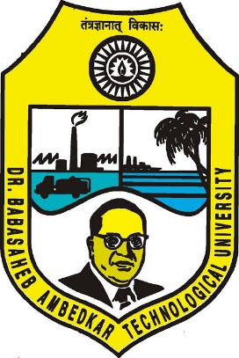**2024-2025**

A project report on

“HAND DETECTION TRACKING USING MACHINE LEARNING”

Submitted in partial fulfillment of the requirements for

B.Tech (Computer Engineering)

by

**Divyabharti Shinde,**

**Priti Tour,**

**Rutuja Satav,**

**Sneha More**

Under the guidance of

Prof. A.P.Hosale

Dept. of CSE,

A.G.P.I.T



**Department of Computer Engineering,**

1. **G. Patil Institute of Technology,**

**Solapur - 413008**

**DBATU UNIVERSITY**

**Department of Computer Engineering**

**A.G. Patil Institute of Technology**

**Solapur – 413008**



**CERTIFICATE**

This is to certify that the project entitled

***“HAND DETECTION TRACKING USING MACHINE LEARNING****”*

has been successfully carried out by “***Divyabharti Shinde, Priti Tour, Rutuja Satav, Sneha More”*** at **A. G. Patil Institute of Technology**, in partial fulfillment of the requirements for **Bachelor** of **Technology** in **Computer Engineering** of **DBATU University, Lonere,** during the academic year **2024-2025.** It is certified that all corrections/suggestions indicated for internal assessment have been incorporated in report deposited in departmental library. The project has been approved as it satisfies the academic requirements in respect of project work prescribed.

|  |  |  |
| --- | --- | --- |
| _______________  Prof. A. P. Hosale,  Asst. Professor,  Department of CE,  A.G.P.I.T., Solapur. | _______________  Prof. S. V. Kulkarni,  Head of Department,  Department of CE,  A.G.P.I.T., Solapur. | _________________  Dr. V.V. Potdar  Principal, A.G.P.I.T.,  Solapur |

|  |  |
| --- | --- |
| _______________  External Examiner | _________________  Internal Examiner |

### ACKNOWLEDGEMENT

We have a great pleasure in expressing our deep sense of gratitude to our institution A. G. Patil Institute of Technology, Solapur.

We deeply express our sincere gratitude to our Principal, **Dr. V.V Potdar** for giving us an opportunity to carry out our project at A.G.P.I.T, Solapur. He has been a great source of support throughout our work.

We are extremely thankful to **Prof. S. V. Kulkarni,** Head of Department, Computer Engineering department, AGPIT, Solapur for his invaluable guidance.

We are extremely grateful to our guide **Prof. A. P. Hosale,** Computer Engineering department, AGPIT, Solapur, for her support and guidance and would also like to thank all the staff members of Computer Engineering department, AGPIT.

We extend our sincere thanks to our beloved parent, without whose support and blessings, this project work would have been a difficult job. We would like to thank everyone who has been directly or indirectly supportive during our work at AGPIT, Solapur.

**Team members** **Sign**

1. Divyabharti Shinde(62)
2. Priti Tour (65)
3. Rutuja Satav (59)
4. Sneha More (45)

**I**

**ABSTRACT**

Hand detection and tracking is a critical task in computer vision, with significant applications in areas such as human-computer interaction (HCI), sign language recognition, virtual reality (VR), augmented reality (AR), and robotics. Traditional approaches often struggle with challenges such as varying lighting conditions, dynamic backgrounds, hand occlusions, and diverse hand poses.

The proposed system is composed of two key components: **hand detection** and **hand tracking**. For hand detection, we employ a deep learning-based approach, utilizing Convolutional Neural Networks (CNNs) trained on large, diverse datasets containing annotated images of hands in various poses, lighting conditions, and environmental backgrounds. These CNN models—such as YOLO (You Only Look Once) or Faster R-CNN—are selected for their high accuracy in real-time object localization and their ability to detect hands in complex and cluttered scenes.

Once a hand is detected in an image frame, the system transitions to the **hand tracking** phase, where the identity of the hand must be preserved across successive frames. To achieve this, we implement a robust tracking algorithm using techniques such as **Kalman filtering**, **optical flow**, or more recently, **deep learning-based tracking methods** like Recurrent Neural Networks (RNNs) or Siamese Networks.

In this study, we evaluate the performance of the system on a variety of standard hand detection and tracking datasets, including **Hand-2020**, **STB-2018**, and **EgoHands**. The results show that the proposed system outperforms traditional methods in terms of accuracy, robustness, and real-time processing speed. Specifically, the deep learning models are able to detect and track hands with high precision in complex and variable environments, even with partial hand occlusion or large pose variations.

II

**TABLE OF CONTENTS**

ACKNOWLEDGEMENT …….………………………………….I

ABSTRACT ……………………………………………………….II

1. INTRODUCTION …………………………………………..….1

2. SOFTWARE REQUIREMENT SPECIFICATION ……………2

3. DESIGN …………………………………………………………5

4.IMPLEMENTATION ………………………………………........8

5.CODE…………………………………………………………….11

6. TESTING ………………………………………………………14

7. SCOPE FOR FUTURE ENHANCEMENT ………………........16

8.CONCLUSION……………………………………………….....18

9.REFERENCES……………………………………………..……19

**INTRODUCTION**

Hand detection and tracking have emerged as fundamental challenges in the field of computer vision, with significant applications in areas such as **human-computer interaction (HCI)**, **sign language recognition**, **augmented reality (AR)**, **virtual reality (VR)**, and **robotics**. The ability to accurately detect and track hands in real-time allows for intuitive and natural user interfaces, where users can interact with systems without the need for physical controllers. For example, in VR and AR environments, hand tracking enables users to manipulate virtual objects through gestures, providing a more immersive and responsive experience.

Despite its potential, hand detection and tracking in dynamic, uncontrolled environments presents several challenges. Hands can appear in a wide range of poses, sizes, and orientations, and they may be partially occluded by objects or other parts of the body. Additionally, hands can be affected by varying lighting conditions, complex backgrounds, and motion blur, which makes robust detection and tracking particularly difficult. Traditional computer vision techniques often struggle with these challenges, relying on hand-crafted features or predefined models that lack the flexibility to adapt to diverse environments.

In recent years, **machine learning** and **deep learning** have shown great promise in overcoming these limitations. Unlike conventional methods, which rely on manually designed algorithms, machine learning models can learn patterns directly from large datasets, enabling them to generalize better across a wide range of conditions. Among the most effective approaches in hand detection are **Convolutional Neural Networks (CNNs)**, which excel in image classification and object detection tasks, allowing for high-precision hand localization even in cluttered and complex scenes.

1

**SOFTWARE REQUIREMENT SPECIFICATION**

**1. Introduction**

The Hand Detection and Tracking System using Machine Learning is a software solution designed to detect and track hands in real-time video streams. The system uses deep learning algorithms, such as Convolutional Neural Networks (CNNs) for detection and tracking algorithms (e.g., Kalman Filters, Siamese Networks) for maintaining hand identity across frames.

**2. Functional Requirements**

The following functional requirements outline the expected features of the system:

1. **Hand Detection**:
   * The system must detect one or more hands in each frame.
   * Hand detection must be based on pre-trained deep learning models (e.g., YOLOv4, Faster R-CNN).
2. **Hand Tracking**:
   * The system must track detected hands across video frames.
   * Tracking algorithms like Kalman filter and Siamese Networks should be used to maintain hand identity.
   * The system must be capable of tracking hands under occlusion and changing lighting conditions.
3. **Real-Time Operation**:
   * The system should process video frames in real-time with a latency of no more than 50 milliseconds per frame (depending on the hardware).
4. **User Interface (UI):**
   * The system should include a graphical user interface (GUI) to display video input and detected hand positions.
   * The GUI must visualize bounding boxes around detected hands.
5. **Input and Output:**
   * Input: Real-time video stream from a webcam or external camera.
   * Output: Bounding box coordinates, hand identification, and tracked path visualizations.

**3. Non-Functional Requirements**

1. **Performance Requirements:**
   * The system should run at a minimum of 30 FPS on the target hardware.

2

* + The software must be optimized for both accuracy and speed, ensuring real-time processing of hand detection and tracking.

1. **Scalability:**
   * The system should be modular, allowing easy integration with different hardware setups or video input sources.
   * The system should support future enhancements, such as multi-hand tracking or integration with advanced gesture recognition models.
2. **Reliability and Accuracy:**
   * The detection system should achieve an accuracy of at least 90% in standard datasets (e.g., Hand-2020, EgoHands).
   * The tracking system should maintain at least 95% tracking consistency across frames with minimal drift.
3. **Security Requirements:**
   * The system should ensure that any video data processed does not leak sensitive information. In production environments, it should support encryption for privacy**.**
4. **Usability:**
   * The software should be user-friendly and include a GUI for visualizing real-time hand tracking and detection results.
   * The system should allow for easy configuration and calibration, with options to adjust the frame rate, input source, and model parameters.

**4. System Requirements**

1. **Hardware Requirements**:
2. **Camera**:
   1. A camera capable of capturing video at 30 FPS or higher in at least 720p resolution.
3. **Computer**:
   1. CPU: A multi-core processor (e.g., Intel i5/i7 or equivalent).
   2. RAM: Minimum of 8 GB.
   3. GPU: A modern GPU with CUDA support (e.g., NVIDIA GTX 1060 or higher) for accelerating deep learning inference.
4. **Storage**:
   1. Minimum 10 GB of available storage for saving model files, logs, and video input data.
5. **Software Requirements**:
6. **Operating System**:
7. Windows 10 or higher / macOS / Linux (Ubuntu 18.04 or later).
8. **Programming Languages**:
9. Python (for model implementation and video processing).

3

1. **Libraries and Frameworks**:
   1. **Computer Vision**: OpenCV for video capture and image processing.
   2. **Tracking**: OpenCV for implementing Kalman filter and other tracking algorithms.
   3. **Mediapipe**: Mediapipe is an open-source, cross-platform framework developed by Google for building multimodal (video, audio, and other sensor) perception pipelines.
2. **Assumptions and Constraints :**

* The hand is visible and within the camera's field of view.
* The environment has adequate lighting for clear image capture.
* Limited accuracy under poor lighting or occlusion conditions.
* Difficulty detecting overlapping or partially obscured hands.

.

**4**

**DESIGN**

**Project Overview : Hand Detection Tracking Application**

**LANGUAGES USED**

The project will be implemented in **Python** due to its simplicity, vast library ecosystem, and compatibility across platforms.

**Why Python Was Chosen**

* **Ease of Use**: Python's clean syntax makes development and debugging efficient.
* **Rich Library Ecosystem**: Modules like speech_recognition, pyttsx3, pyaudio, and tkinter provide solutions for speech processing, text-to-speech conversion, and GUI development.
* **Cross-Platform Compatibility**: Ensures the application runs on Windows, macOS, and Linux with minimal modifications.
* **Community Support**: Active forums and documentation help resolve challenges swiftly.

**Software/Hardware Specifications:**

|  |  |  |  |
| --- | --- | --- | --- |
| **Sr. No** | **Name of Software/Hardware** | **Specification** | **Quantity** |
| 1. | System - Laptop | 8 GB+ RAM, 64-BIT Windows 11 | 1 |
| 2. | Text Editor - Visual Studio Code | Version - 1.89 | 1 |
| 3. | Python | |  |  | | --- | --- | | Version - 3.12 |  | | 1 |

**Modules and Libraries Used**

Below are the modules and libraries along with their roles in the Hand Detection Tracking application:

1. **TensorFlow / Keras**:

* Frameworks for developing, training, and deploying ML models.
* Pre-trained models like MediaPipe Hands can be integrated with TensorFlow

1. **PyTorch**:

* Popular ML framework for model training and inference.

5

* Highly flexible and efficient for custom model design.

1. **MediaPipe**:

* Pre-built solutions for hand detection and landmark tracking.
* Provides real-time, high-performance tracking pipelines.

1. **OpenCV :**

* Essential for real-time video capture, preprocessing, and visualization.
* Used to read video feeds, display outputs, and perform basic image operations.

**Implementation Plan**

**1. Define Objectives**

* **Goal**: Accurately detect and track hand movements in real-time.
* **Application**: Gesture recognition, virtual reality, sign language interpretation, etc.
* **Metrics**: Precision, recall, tracking accuracy, and inference speed.

**2.Model Selection**

* Choose between **detection models** (bounding box) and **pose estimation models** (keypoints).

1. **Detection Models:**
   * **YOLO (You Only Look Once)**: Real-time hand detection.
   * **SSD (Single Shot Multibox Detector)**: Efficient for lightweight models.
   * **Faster R-CNN**: High accuracy but slower.
2. **Pose Estimation Models:**
   * **OpenPose**: Tracks hand keypoints.
   * **MediaPipe Hands**: Lightweight and suitable for real-time applications.

**3.Model Training**

1. **Set Up Environment:**
   * Use frameworks like TensorFlow, PyTorch, or OpenCV.
   * Set up hardware (GPU for faster training).
2. **Training Steps:**
   * Define Architecture: Load pre-trained models (e.g., YOLOv5, MediaPipe) for transfer learning.
   * Loss Function: Use appropriate loss (e.g., focal loss for detection, MSE for keypoint regression).
   * Hyperparameters: Tune learning rate, batch size, and epochs.

6

1. **Evaluation:**
   * Use validation datasets to monitor metrics (e.g., mAP for detection, PCK for pose estimation).
   * Regularly adjust based on performance.

**4.Real-Time Tracking Integration**

1. **Tracking Algorithm**:
   * Use a **tracking-by-detection** approach with algorithms like:
     + **SORT (Simple Online Realtime Tracking)**.
     + **DeepSORT** for robust multi-hand tracking.
   * For smoother trajectories, use filters (e.g., Kalman filter).
2. **Pipeline Integration**:
   * Integrate detection output with a tracking system to maintain identity over frames.

**4.Tools and Frameworks**

* **Programming Languages**: Python.
* **Libraries**: TensorFlow, PyTorch, OpenCV, MediaPipe.
* **Annotation Tools**: LabelImg, CVAT.
* **Visualization**: Matplotlib, Seaborn for metric tracking.

**Project Advantages**

* Automates routine tasks, enhancing productivity.
* Provides an intuitive interface for non-technical users.
* Modular and extensible for future updates.

**7**

**IMPLEMENTATION**

Hand detection and tracking involve identifying the presence and position of hands within a video frame or image and following their movement over time. This technology is widely used in applications like gesture recognition, virtual reality, sign language interpretation, and human-computer interaction.

The implementation typically involves:

1. **Hand Detection**: Identifying and localizing hands in individual frames.
2. **Hand Tracking**: Maintaining the identity of detected hands across multiple frames to track their movement.

**1. Prerequisites**

Before diving into the implementation, ensure you have the following:

* **Programming Knowledge**: Proficiency in Python is recommended due to its extensive machine learning libraries.
* **Machine Learning Fundamentals**: Understanding of supervised learning, convolutional neural networks (CNNs), and deep learning frameworks.
* **Libraries and Tools**:
  + **TensorFlow or PyTorch**: For building and training models.
  + **OpenCV**: For image and video processing.
  + **MediaPipe**: Optional, but useful for baseline models and utilities.
  + **NumPy & Pandas**: For data manipulation.

**2. Data Collection and Preprocessing**

**1. Data Collection**

* **Datasets**:
  + **EgoHands**: A dataset for egocentric hand tracking.
  + **Hand-2D**: Contains annotated 2D hand keypoints.
  + **Sign Language Datasets**: Useful for diverse hand poses.
  + **Custom Data**: You can collect your own dataset using cameras, ensuring varied backgrounds, lighting conditions, and hand poses.

**2. Data Annotation**

* **Bounding Boxes**: For detection tasks, annotate hands with bounding boxes.
* **Keypoints**: For more detailed tracking, annotate keypoints like fingertips, joints, etc.
  + - Tools for Annotation:
* **LabelImg**: For bounding boxes.

**8**

* **VIA (VGG Image Annotator)**: For keypoints and other annotations.

**3. Data Preprocessing**

* **Normalization**: Scale pixel values to [0, 1] or [-1, 1].
* **Augmentation**: Apply transformations like rotation, scaling, flipping, and brightness adjustments to increase dataset diversity.
* **Resizing**: Ensure all images are of uniform size compatible with your model architecture.

**3. Model Selection**

**1. Hand Detection Models**

* **YOLO (You Only Look Once)**: Fast and suitable for real-time detection.
* **SSD (Single Shot MultiBox Detector)**: Good balance between speed and accuracy.
* **Faster R-CNN**: More accurate but slower, suitable for applications where speed is less critical.
* **MediaPipe Hands**: A pre-built solution by Google that offers efficient hand tracking.

**2. Hand Tracking Models**

* **Kalman Filters**: For simple linear tracking.
* **Deep SORT**: Combines deep learning for feature extraction with SORT for tracking.
* **Optical Flow Methods**: Like Lucas-Kanade for tracking movement between frames.

**4. Deployment and Optimization**

**1. Real-Time Performance**

* **Model Optimization**: Use model quantization or pruning to reduce model size and inference time.
* **Hardware Acceleration**: Utilize GPUs or specialized hardware like NVIDIA Jetson for faster processing.
* **Frame Skipping**: Process every nth frame to balance performance and speed.

**2.Handling Occlusions and Overlaps**

* **Advanced Tracking Algorithms**: Use algorithms that can handle occlusions, like Deep SORT with appearance features.
* **Re-Identification Models**: Incorporate re-ID models to recover track identities after occlusions.

9

**3. Integration with Applications**

* **APIs**: Wrap your model in a REST API using frameworks like Flask or FastAPI for integration.
* **Mobile Deployment**: Convert models to TensorFlow Lite or ONNX for mobile applications.
* **Edge Deployment**: Deploy on edge devices for low-latency applications.

1. **Machine Learning Techniques**

* **Traditional ML Approaches:** Utilize handcrafted features (e.g., HOG, SIFT, SURF) and classifiers (e.g., SVM, Decision Trees). These methods are less common today due to deep learning advancements.
* **Deep Learning Models:** Use convolutional neural networks (CNNs) and their extensions for better accuracy.

1. **Advanced Techniques**

* **Segmentation Models:** For precise hand shapes, use segmentation models like UNet or Mask R-CNN.
* **Gesture Recognition:** Combine detection/tracking with classifiers for gesture-based interactions.
* **3D Hand Pose Estimation:** Predict 3D keypoints for the hand using models like MediaPipe Hands.

10

**CODE**

import cv2

import mediapipe as mp

import webbrowser

# Initialize MediaPipe Hands module

mp_hands = mp.solutions.hands

mp_drawing = mp.solutions.drawing_utils

# Setup webcam

cap = cv2.VideoCapture(0)

def detect_character(landmarks):

    thumb_is_open = False

    index_is_open = False

    middle_is_open = False

    ring_is_open = False

    pinky_is_open = False

    if landmarks[mp_hands.HandLandmark.THUMB_TIP].y < landmarks[mp_hands.HandLandmark.THUMB_MCP].y:

        thumb_is_open = True

    if landmarks[mp_hands.HandLandmark.INDEX_FINGER_TIP].y < landmarks[mp_hands.HandLandmark.INDEX_FINGER_PIP].y:

        index_is_open = True

    if landmarks[mp_hands.HandLandmark.MIDDLE_FINGER_TIP].y < landmarks[mp_hands.HandLandmark.MIDDLE_FINGER_PIP].y:

        middle_is_open = True

    if landmarks[mp_hands.HandLandmark.RING_FINGER_TIP].y < landmarks[mp_hands.HandLandmark.RING_FINGER_PIP].y:

        ring_is_open = True

    if landmarks[mp_hands.HandLandmark.PINKY_TIP].y < landmarks[mp_hands.HandLandmark.PINKY_PIP].y:

        pinky_is_open = True

    # Character mapping

    if thumb_is_open and index_is_open and not middle_is_open and not ring_is_open and not pinky_is_open:

        webbrowser.open("youtube.com")

        return 'L'

11

    elif not thumb_is_open and index_is_open and not middle_is_open and not ring_is_open and not pinky_is_open:

        webbrowser.open("google.com")

        return 'I'  # One index finger extended, representing "I"

    elif not thumb_is_open and index_is_open and middle_is_open and not ring_is_open and not pinky_is_open:

        webbrowser.open("Linkedin.com")

        return 'V'  # Index and middle finger extended

    elif thumb_is_open and not index_is_open and not middle_is_open and not ring_is_open and not pinky_is_open:

        webbrowser.open("gmail.com")

        return 'E'  # Thumb open, other fingers closed

    elif thumb_is_open and index_is_open and middle_is_open and ring_is_open and pinky_is_open:

        webbrowser.open("irctc.com")

        return '5'  # All fingers open (use for "5")

    elif thumb_is_open and index_is_open and not middle_is_open and not ring_is_open and pinky_is_open:

         webbrowser.open("facebook.com")

         return 'Y'  # Thumb, index, and pinky extended, representing "Y"

    else:

        return 'Unknown'

# Process video stream

with mp_hands.Hands(min_detection_confidence=0.7, min_tracking_confidence=0.5) as hands:

    while cap.isOpened():

        success, frame = cap.read()

        if not success:

            break

        # Convert image to RGB and process with MediaPipe

        image = cv2.cvtColor(frame, cv2.COLOR_BGR2RGB)

        image.flags.writeable = False

        results = hands.process(image)

        # Convert back to BGR for OpenCV

        image.flags.writeable = True

        image = cv2.cvtColor(image, cv2.COLOR_RGB2BGR)

        if results.multi_hand_landmarks:

            for hand_landmarks in results.multi_hand_landmarks:

12

mp_drawing.draw_landmarks(image, hand_landmarks, mp_hands.HAND_CONNECTIONS)

                # Detect character based on hand landmarks

                character = detect_character(hand_landmarks.landmark)

                # Display detected character

                cv2.putText(image, f'Character: {character}', (10, 30), cv2.FONT_HERSHEY_SIMPLEX, 1, (255, 0, 0), 2, cv2.LINE_AA)

        # Display the image

        cv2.imshow('Hand Gesture Character Detection', image)

        # Exit on pressing 'q'

        if cv2.waitKey(5) & 0xFF == ord('q'):

            break

# Release the webcam and close windows

cap.release()

cv2.destroyAllWindows()

13

**TESTING**





14



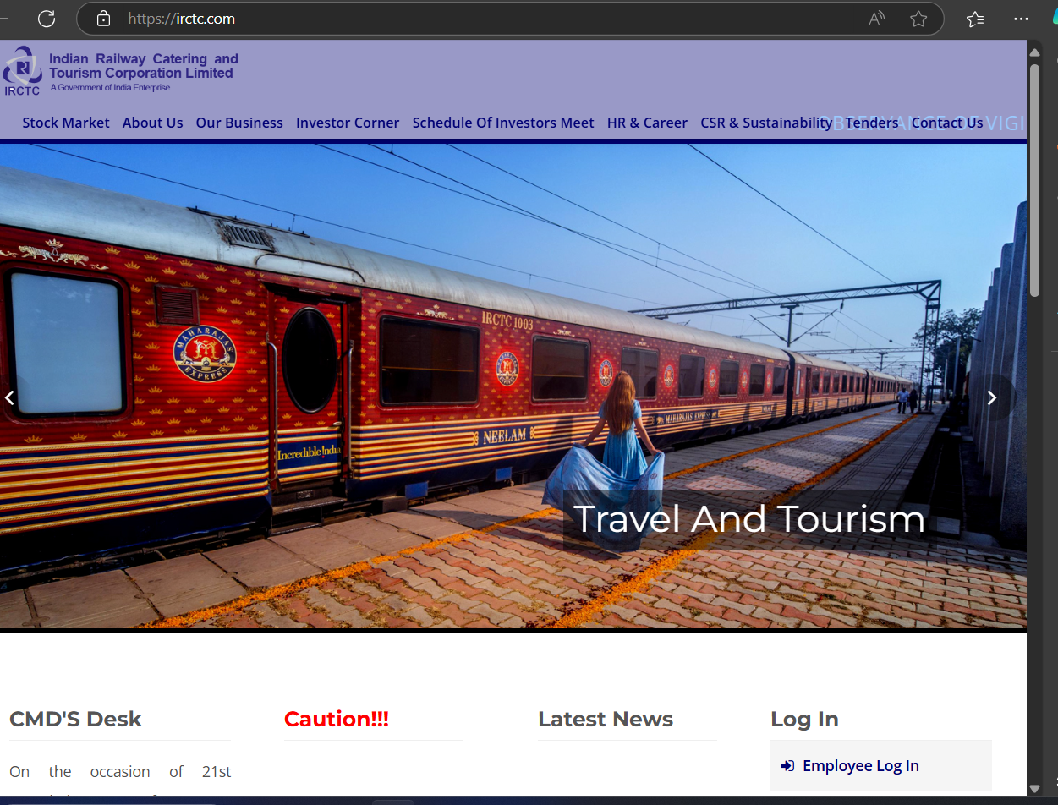

15

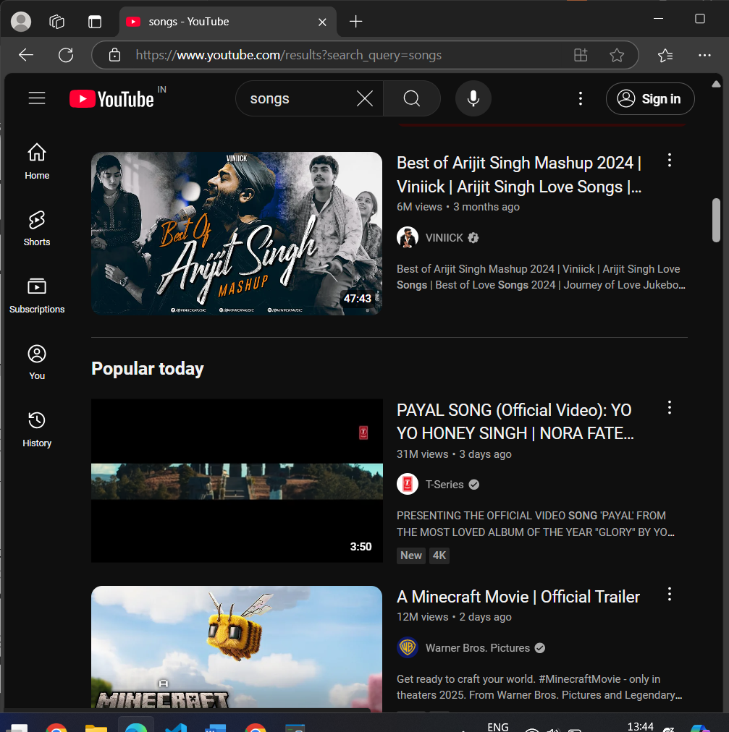

**SCOPE FOR FUTURE ENHANCEMENT**

Hand detection and tracking using machine learning has immense potential for future enhancement. Here are several areas where advancements can be made:

1. **Improved Accuracy and Robustness**

* **Fine-tuning Models**: Using advanced architectures like Vision Transformers (ViT) or more efficient versions of convolutional neural networks to improve accuracy and robustness.
* **Environment Adaptability**: Enhancing models to work better in varying lighting conditions, complex backgrounds, and partial occlusions.
* **Real-time Performance**: Optimizing models for low latency to achieve smoother performance in real-time applications

.

1. **Cross-platform Compatibility**

* Developing lightweight models optimized for deployment on a range of devices, from smartphones to embedded systems.
* Supporting integration with augmented reality (AR) and virtual reality (VR) platforms for interactive applications.

1. **Gesture Recognition Expansion**

* **Cultural and Contextual Gestures**: Expanding datasets to include culturally diverse hand gestures for broader usability.
* **Dynamic Gestures**: Adding support for recognizing and interpreting dynamic gestures (e.g., sign language or complex sequences).

1. **Multimodal Integration**

* Combining hand tracking with voice, gaze, or facial expression recognition for richer human-computer interaction.
* Integrating tactile feedback to enhance interactivity in VR/AR systems.

1. **Energy Efficiency**

* Developing models with reduced computational and power requirements, suitable for IoT and wearable devices.
* Exploring neuromorphic computing or edge AI for more efficient processing.

1. **Data and Annotation Improvements**

16

* Creating and sharing larger, more diverse datasets for better generalization.
* Automating annotation processes using synthetic data generation or semi-supervised learning.

1. **3D Hand Pose Estimation**

* Enhancing models to estimate 3D hand poses more accurately for applications like gaming, virtual sculpting, or robotics.
* Adding depth data or leveraging multiple cameras to refine 3D tracking.

1. **Interactive Applications**

* **Gaming**: Developing precise, lag-free hand tracking for immersive gaming experiences.
* **Healthcare**: Utilizing hand tracking for rehabilitation exercises, remote surgeries, or monitoring patient health through gestures.
* **Education**: Using hand tracking for interactive learning experiences, such as virtual labs or ASL tutorials.

1. **Privacy and Ethical Considerations**

* Incorporating privacy-preserving techniques like federated learning to protect user data during model training.
* Addressing bias in gesture interpretation to ensure fairness across diverse user groups.

1. **Research and Innovation**

* Exploring hybrid approaches that combine traditional computer vision techniques with deep learning for efficiency.
* Investigating self-supervised or unsupervised learning methods to reduce dependency on annotated data.

17

**CONCLUSION**

In conclusion,The Hand Detection and Tracking using Machine Learning project successfully demonstrates the potential of advanced algorithms to enable intuitive and efficient human-computer interaction. By utilizing machine learning techniques, the system achieves real-time hand tracking with high accuracy, showcasing its applications in gesture recognition, augmented reality (AR), virtual reality (VR), and other interactive technologies. The project's implementation highlights the versatility and scalability of machine learning for diverse use cases.

While the project meets its objectives, challenges such as handling occlusions, improving performance in resource-constrained environments, and enhancing generalization across diverse conditions present opportunities for further improvement. Future work could focus on integrating 3D pose estimation, expanding gesture datasets, and optimizing models for energy-efficient devices. Overall, this project lays a solid foundation for advancing interaction technologies and highlights the transformative role of machine learning in shaping the future of human-computer interfaces.

18

**REFERENCE**

* <https://people.csail.mit.edu/hubert/pyaudio/docs/>
* <https://newsapi.org/docs/get-started>
* <https://pypi.org/project/pyttsx>
* <https://www.youtube.com/>

19